BIG DATA ANALYTICS PROJECT
TELANGANA RICE MILL
TRANSACTION ANALYTICS
Operational Performance, Production Yield, Cost and Delivery Insights
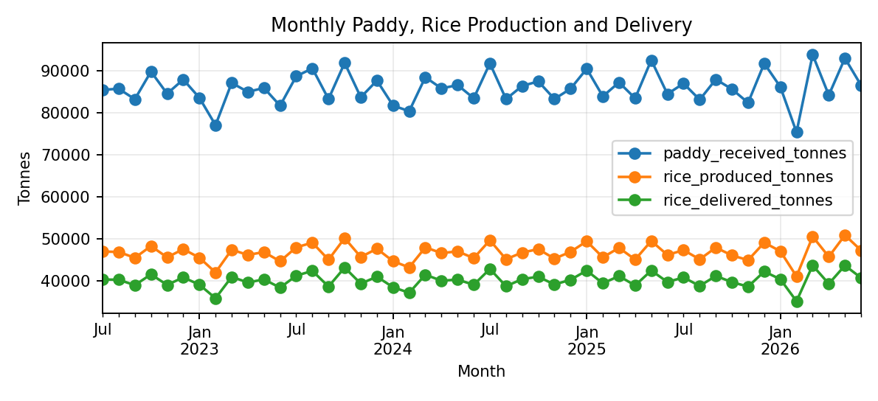

PROJECT DETAIL | INFORMATION
Student Name | Sathwika Mullapudi
Programme | PGDM – Finance and Data Analytics
Institution | Badruka School of Management
Course | Big Data Analytics
Faculty Guide | [Enter faculty guide name]
Submission Date | 29 October 2026

Dataset: Telangana Rice Mill Transactions (100,000 records) | Period: 1 July 2022–30 June 2026
Prepared as an academic analytics prototype. Dataset records are marked SYNTHETIC; results are not real-world operational claims.

Report Structure & Submission Notes
Thirty-page report structure aligned to the reference report while using the supplied rice-mill dataset.
Page | Section | Page | Section
1 | Cover page | 16 | Rice-type analysis
2 | Contents and integrity | 17 | District-level performance
3 | Executive summary | 18 | Seasonal analysis
4 | Business problem | 19 | Delivery timeliness
5 | Objectives and scope | 20 | Cost analysis
6 | Dataset inventory | 21 | Data quality
7 | Data dictionary | 22 | Python methodology
8 | Methodology | 23 | Forecasting / analytical modelling
9 | Architecture | 24 | PostgreSQL and DBeaver
10 | Data model | 25 | Databricks and PySpark
11 | Delta Lake layers | 26 | Power BI dashboard
12 | KPI definitions | 27 | Recommendations
13 | Descriptive overview | 28 | Risks and limitations
14 | Monthly trends | 29 | Conclusion and future work
15 | Production and delivery | 30 | Appendix and reproducibility

Integrity and provenance
All 100,000 rows in the supplied CSV have data_status = SYNTHETIC. Reported values are calculated from that file and are useful for demonstrating a reproducible workflow, not for claiming actual performance of Telangana mills. The report does not claim that PostgreSQL, Databricks, Delta Lake or Power BI have been executed unless the student captures evidence from those tools.

Before submission
- Replace the faculty-guide placeholder if required by your institution.
- Run the SQL/Python/notebook components and insert genuine screenshots where available.
- Do not publish passwords, access tokens or private workspace URLs in GitHub.

Executive Summary
The supplied dataset contains 100,000 transaction records and 32 columns, covering 2022-07-01 through 2026-06-30. It represents 500 mill IDs across 33 districts and 157 mandals. All rows are labelled SYNTHETIC.
Indicator | Observed value | Interpretation
Transactions | 100,000 | Transaction-like operational records
Paddy received | 4,127,695.36 tonnes | Sum of supplied paddy received
Paddy processed | 3,357,466.83 tonnes | Sum of supplied paddy processed
Rice produced | 2,242,223.24 tonnes | Sum of supplied rice production
Rice delivered | 1,928,388.49 tonnes | Sum of supplied rice delivery
Recorded cost components | ₹3,268,288,131.94 | Labour + transport + storage + milling costs
Missing cells | 1,499 | Concentrated in four columns
Exact duplicate rows | 0 | Full-row duplicate check

Aggregate conversion ratio is 66.78% (rice produced divided by paddy processed). Recorded rice delivered equals 86.00% of recorded rice produced, but these totals are not necessarily a same-cohort fulfilment rate.
Among 99,700 rows with both due and actual delivery dates, 72,683 (72.7%) have a positive date difference. This result requires checking date-generation logic because the dataset is synthetic.
The recommended workflow uses Python/pandas for profiling and analysis; PostgreSQL for structured storage and SQL; DBeaver as the database client; Databricks/PySpark for scalable transformations; Delta Lake for Bronze/Silver/Gold tables; and Power BI for management reporting.

Business Problem & Decision Context
Rice milling operations connect paddy procurement, processing, rice recovery, storage, dispatch and delivery. Managers need a consolidated view of throughput, production yield, operating cost and delivery timeliness. When these indicators sit in separate files, it becomes difficult to compare mill types, districts, seasons and product types consistently.

Core business question
How can a repeatable big-data analytics workflow help stakeholders monitor rice-mill throughput, conversion yield, cost composition and delivery delays across Telangana districts?

Questions addressed
- How much paddy is received and processed, and how much rice is produced and delivered?
- How do output and cost profiles vary by district, season, mill type and rice type?
- What share of deliveries is recorded after the due date?
- Which cost components contribute most to the recorded total?
- What data-quality gaps should be resolved before operational use?
- How can the data be structured for SQL analysis and Power BI reporting?

Decision boundary
The report supports monitoring and prioritization, not automated procurement or mill scheduling. It does not contain verified energy tariffs, paddy purchase prices, rice selling prices, machine-level telemetry or a complete production calendar. Costs are recorded cost components, not a complete profitability statement.

Objectives, Scope & Success Criteria
Objective | Deliverable | Evidence of completion
Profile source data | Data quality report | Rows, types, missingness, duplicates, date range
Measure operations | KPI summary tables | Reconciled aggregate totals
Model structured data | PostgreSQL schema | Keys, constraints, row counts
Answer business questions | SQL queries | Saved query outputs
Create repeatable analysis | Python pipeline | Run log and exported summaries
Demonstrate big-data layers | Spark/Delta notebook | Successful run and table counts or clearly marked plan
Support decisions | Power BI dashboard | KPI cards, visuals and slicers
Make work reproducible | GitHub repository | README, dependencies, scripts and no secrets

In scope
- Descriptive analysis of production, delivery, costs, seasonality and delays.
- Data modelling, data quality validation and cross-tool KPI reconciliation.
- A scalable implementation design using PostgreSQL, DBeaver, Databricks, Delta Lake, Python and Power BI.

Out of scope
Live government procurement integration, real-time streaming, causal inference, predictive maintenance, production MLOps and automated operational decisions are outside the current dataset and submission scope.

Dataset Inventory & Structure
Property | Observed value | Notes
Source file | telangana_rice_mill_transactions_100k.csv | User-provided CSV
Rows / columns | 100,000 × 32 | 100,000 records and 32 columns
Date coverage | 2022-07-01 to 2026-06-30 | Four-year date range
Mill IDs | 500 | 500 distinct mill identifiers
Districts | 33 | 33 distinct district labels
Mandals | 157 | 157 distinct mandal labels
Season records | Rabi 50,035; Kharif 49,965 | Nearly balanced
Data status | 100% SYNTHETIC | Not live government or mill records

Field groups
Group | Fields | Analytical role
Identifiers | transaction_id, mill_id | Record identity and mill grouping
Geography | district, mandal | Regional aggregation
Classification | season, mill_type, rice_type, paddy_variety, procurement_source | Segmentation and filtering
Quantities | paddy_received_tonnes, paddy_processed_tonnes, rice_produced_tonnes, rice_delivered_tonnes, rice_not_yet_delivered_tonnes | Material flow indicators
Operating conditions | moisture_percentage, electricity_kwh, installed_capacity_tonnes_day, mill_operating_hours, machine_downtime_hours | Efficiency context
Costs | labour_cost_inr, transport_cost_inr, storage_cost_inr, milling_cost_inr | Cost composition
Dates/status | transaction_date, delivery_due_date, actual_delivery_date, data_status | Trend and timeliness analysis

Data Dictionary & Business Rules
Field | Type | Definition / rule
transaction_id | Text | Unique transaction-like identifier; validate uniqueness
mill_id | Text | Mill identifier; use as a grouping dimension
transaction_date | Date | Date associated with the record
district / mandal | Text | Geographic labels; standardize spelling/case
season | Category | Kharif or Rabi in supplied records
mill_type | Category | Custom Milling Unit, Raw Rice Mill, Parboiled Rice Mill
rice_type | Category | Raw Rice or Parboiled Rice
paddy_received_tonnes | Decimal | Paddy received for the record
paddy_processed_tonnes | Decimal | Paddy processed for the record
rice_produced_tonnes | Decimal | Rice output recorded
rice_delivered_tonnes | Decimal | Rice delivery recorded
moisture_percentage | Decimal | Moisture measurement; missing values present
electricity_kwh | Decimal | Recorded electricity consumption
*_cost_inr | Decimal | Labour, transport, storage and milling cost fields
installed_capacity_tonnes_day | Integer | Installed daily capacity label
mill_operating_hours | Decimal | Operating hours recorded
machine_downtime_hours | Decimal | Downtime hours recorded
delivery_due_date / actual_delivery_date | Date | Due and actual delivery dates; actual date has missing values
rice_not_yet_delivered_tonnes | Decimal | Supplied not-yet-delivered quantity; definition requires validation

Derived indicators
- Conversion ratio (%) = total rice produced ÷ total paddy processed × 100.
- Delivery-date difference (days) = actual delivery date − due date; positive means late.
- Recorded cost total = labour + transport + storage + milling costs, only when all components are present.
- Delivery-to-production ratio is an aggregate comparison, not a transaction-cohort fulfilment measure.

Methodology & Analytical Workflow
• Preserve the original CSV and record source name, row count and file metadata.
• Profile schema, missing values, duplicates, date coverage, category values and numeric ranges in Python.
• Standardize column names and parse date fields; retain missingness indicators rather than silently imputing values.
• Calculate descriptive KPIs at documented grains and produce chart-ready aggregate files.
• Create PostgreSQL staging and analytical tables; use DBeaver to execute and inspect SQL.
• Use Databricks/PySpark to read, validate, transform and write Delta tables where workspace permissions allow.
• Build Power BI pages using validated Gold aggregates or a controlled PostgreSQL connection.
• Reconcile row counts and KPIs across Python, SQL and Power BI; document differences before submission.
• Package scripts, SQL, notebook source, report, dataset notes and setup instructions in GitHub.

Why this sequence?
Profiling before transformation makes missingness and source anomalies visible. Explicit KPI definitions prevent different tools from calculating the same measure differently. Layered storage separates raw records from validated data and presentation-ready aggregates. Each tool’s completion status must be backed by execution evidence.

Solution Architecture
Layer | Technology | Responsibility | Evidence to capture
Source | CSV | Original records and provenance | File name, shape, data status
Validation | Python / pandas | Schema checks, cleaning, profiling and summaries | Console log and output files
Relational storage | PostgreSQL | Tables, constraints, indexes and SQL analytics | Schema and query result
SQL client | DBeaver | Connection, import, query authoring | Connection and results; hide credentials
Distributed compute | Databricks / PySpark | Scalable data transformations | Notebook run and counts
Lakehouse storage | Delta Lake | Bronze/Silver/Gold tables | Successful writes and table history
BI layer | Power BI | KPI cards, trends, comparisons and filters | Actual report pages and refresh status
Version control | GitHub | Code, documentation and reproducibility | Repository URL and README

Logical flow
CSV → Python validation → PostgreSQL staging/analytics → Databricks/PySpark → Delta Lake Bronze/Silver/Gold → Power BI → GitHub documentation.
This is the target logical architecture. It is not proof that every connection has been completed. The final submission should label each component as executed, partially executed or planned based on actual evidence.

Relational Model & Table Design
A normalized model separates repeated mill and geography attributes from transaction-level measures. The proposed fact grain is one row per transaction_id, with mill and calendar dimensions added when available.
Table | Primary key | Selected columns | Purpose
stg_rice_transactions | transaction_id (validate) | All source fields | Landing zone preserving imported values
dim_mill | mill_id | district, mandal, mill_type, capacity | Mill attributes; check consistency over time
dim_date | date_key | date, year, month, quarter, season | Calendar filtering
fact_mill_transactions | transaction_id | Quantities, costs, dates, operating fields | Operational measurements
gold_district_month | district + month | Production, delivery, costs, counts | Dashboard aggregate

Design rationale
- Keep source transaction identifiers for traceability.
- Use foreign keys only after dimension uniqueness is validated.
- Treat capacity as time-varying if the same mill has changing capacity records.
- Use decimal types for tonnes, kWh and INR values; do not use floating point for final financial reconciliation.
- Index transaction_date, mill_id and district for common filters and joins.

Load sequence
Create staging first, validate identifiers and categories, then load dimensions and facts. Compare source and target row counts. Where multiple records exist per mill and date, retain transaction-level grain unless a documented aggregation is intended.

Delta Lake & Medallion Layers
Layer | Content | Quality rule | Consumer
Bronze | Raw ingested records | Preserve source fields and ingestion timestamp | Audit / replay
Silver | Standardized, typed records | Date parsing, missingness flags, valid ranges and duplicate checks | Analytics engineering
Gold | Business aggregates and model outputs | Reconciled totals and explicit grain/KPI definitions | Power BI / decision support

Delta Lake stores data in Parquet with a transaction log to support reliable table operations such as ACID transactions and schema enforcement. A medallion pattern is useful when each layer has a clear purpose and quality contract.

Validation tests
- Record count and date range reconcile to the source.
- transaction_id uniqueness is checked; duplicate handling is documented.
- Missing dates and numeric values are flagged, not silently converted to zero.
- Invalid negative quantities or costs are quarantined for review.
- Repeated notebook runs do not append the same file twice unintentionally.
- Table paths, permissions and retention settings are documented.

Execution note
The report provides the intended design. Mark Databricks/Delta as complete only after a successful notebook run and table-count evidence are captured in the workspace.

KPI Dictionary & Calculation Rules
KPI | Definition | Caution
Paddy received | SUM(paddy_received_tonnes) | Quantity recorded; not necessarily unique procurement volume
Paddy processed | SUM(paddy_processed_tonnes) | Validate against mill capacity and dates
Rice produced | SUM(rice_produced_tonnes) | Production volume in supplied data
Aggregate conversion ratio | SUM(rice produced) / SUM(paddy processed) | Weighted aggregate; not average row yield
Rice delivered | SUM(rice_delivered_tonnes) | Delivery quantity recorded
Recorded cost total | SUM(labour + transport + storage + milling) | Only comparable if components are complete
Late delivery share | Rows with actual_date > due_date / rows with both dates | Synthetic date rules may influence result
Average downtime | AVG(machine_downtime_hours) | Review extreme values and units
Pending delivery quantity | SUM(rice_not_yet_delivered_tonnes) | Source definition and overlap require validation

Reconciliation protocol
Calculate each KPI with the same filters in Python and SQL. Investigate differences caused by missing values, join multiplication, decimal rounding, date filters or duplicated transaction identifiers. Do not average conflicting results.

Descriptive Overview
Measure | Total / value | Average per row
Paddy received | 4,127,695.36 t | 41.28 t
Paddy processed | 3,357,466.83 t | 33.57 t
Rice produced | 2,242,223.24 t | 22.42 t
Rice delivered | 1,928,388.49 t | 19.28 t
Electricity | 36,695,140.75 kWh | 368.42 kWh
Milling cost | ₹1,745,993,386.88 | ₹17,459.93
Downtime | 155,594.82 h | 1.56 h
Pending delivery field | 313,834.75 t | 3.14 t

The aggregate conversion ratio is 66.78%. This is a ratio of totals, and it differs conceptually from averaging individual transaction yield percentages.
The dataset has near-equal numbers of Kharif and Rabi records, and records cover 500 mill IDs. Since the file is synthetic, balance in record counts may be a design choice rather than evidence of equal real-world activity.

Monthly Production & Delivery Trends
Figure 1. Monthly paddy received, rice produced and rice delivered across the supplied date range.
The monthly trend gives a compact view of throughput and the relationship between processing output and delivery. Compare received and processed paddy with rice produced; differences may reflect processing yield, timing or how the synthetic records were generated.
- Check whether each month is represented and whether unusual spikes coincide with changes in record count.
- Compare production and delivery by season and mill type before making operational conclusions.
- Do not infer long-term agricultural trends from a synthetic dataset.
- Use transaction counts alongside totals so that high-volume months are not confused with higher average activity.

Production, Delivery & Conversion
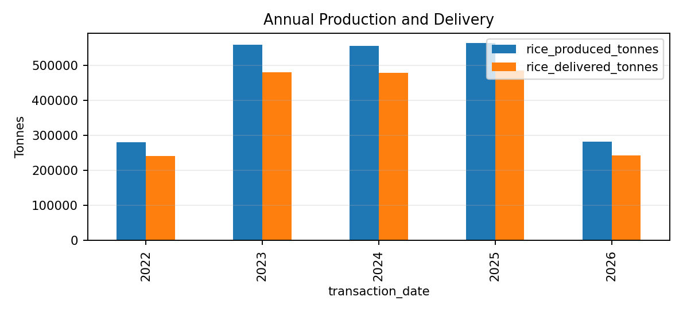
Indicator | Value
Paddy processed | 3,357,466.83 tonnes
Rice produced | 2,242,223.24 tonnes
Rice delivered | 1,928,388.49 tonnes
Aggregate conversion ratio | 66.78%
Delivery-to-production ratio | 86.00%

Figure 2. Annual production and delivery totals. Rice delivered in a period may relate to rice produced in earlier periods; therefore, the aggregate delivery-to-production ratio is a comparison of totals, not proof of fulfilment for the same production cohort.

Rice-Type Analysis
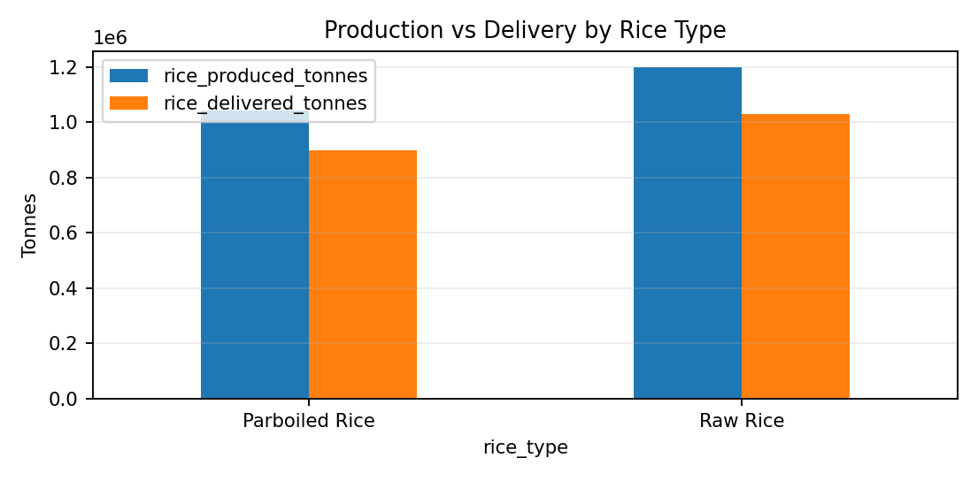
Rice type | Records | Rice produced (t) | Rice delivered (t)
Raw Rice | 51794 | 1,198,494.72 | 1,030,357.85
Parboiled Rice | 48206 | 1,043,728.52 | 898,030.64

Figure 3. Comparison of production and delivery by rice type. Differences may reflect production mix, record counts and the synthetic data-generation process. A fair comparison should include per-record averages and mill-level distributions, not totals alone.

District-Level Performance
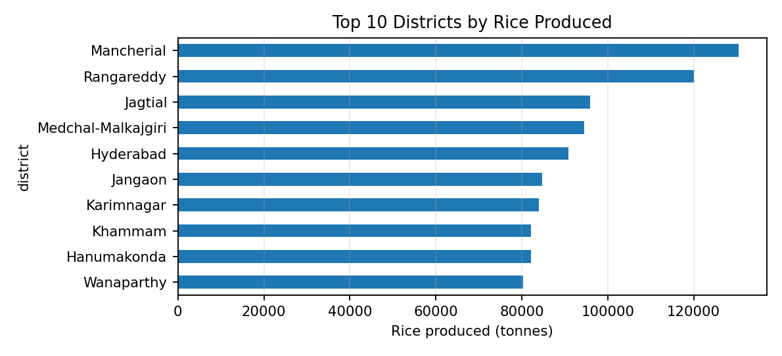
Rank | District | Records | Rice produced (t) | Rice delivered (t)
1 | Mancherial | 4571 | 130,511.88 | 112,236.11
2 | Rangareddy | 4959 | 120,061.51 | 103,053.58
3 | Jagtial | 4102 | 95,888.41 | 82,283.28
4 | Medchal-Malkajgiri | 3955 | 94,500.36 | 81,354.69
5 | Hyderabad | 3526 | 90,820.06 | 78,093.06

Figure 4. Top 10 districts by recorded rice production. Mancherial has the highest recorded production total in the supplied dataset. This ranking should not be interpreted as an official district ranking because the data is synthetic.

Seasonal & Mill-Type Analysis
Season | Records | Paddy received (t) | Rice produced (t) | Rice delivered (t)
Kharif | 49965 | 2,062,041.06 | 1,120,630.16 | 964,115.28
Rabi | 50035 | 2,065,654.30 | 1,121,593.08 | 964,273.21

Mill type | Records | Rice produced (t) | Recorded cost total (INR)
Custom Milling Unit | 34856 | 813,728.86 | ₹1,191,741,017.09
Parboiled Rice Mill | 30751 | 637,242.91 | ₹918,234,003.35
Raw Rice Mill | 34393 | 791,251.47 | ₹1,158,313,111.50

Kharif and Rabi totals are broadly similar in the supplied dataset. Custom Milling Units contribute the largest total production among mill types, though the category also has the largest number of records. Compare per-record measures before interpreting differences as operational efficiency.

Delivery Timeliness & Delay Analysis
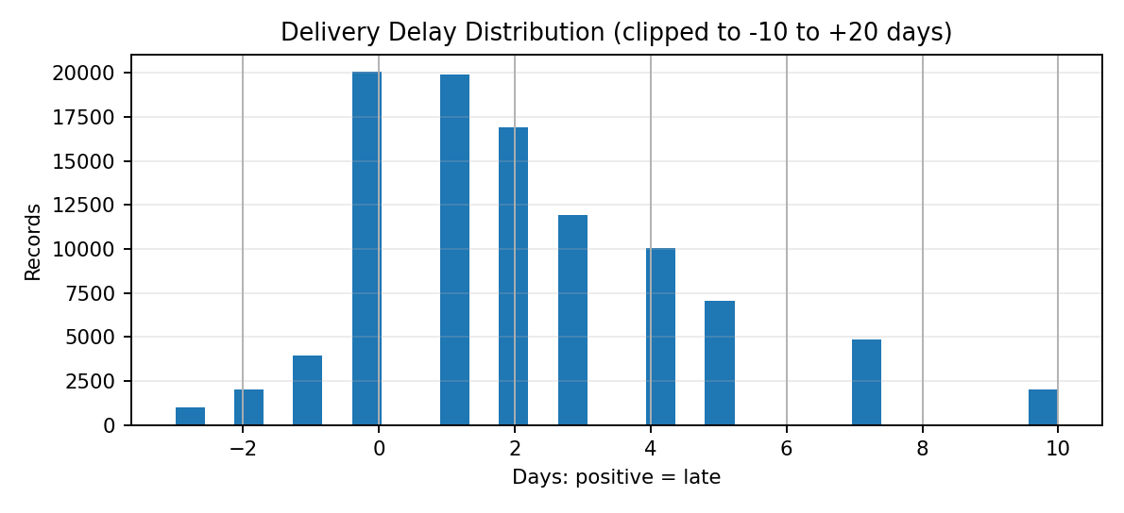
Indicator | Result
Rows with both due and actual date | 99,700
Rows after due date | 72,683
Positive-delay share | 72.68%
Rows on/before due date | 27,017
Average date difference | 2.09 days

Figure 5. Delivery date difference; positive values indicate late delivery. The unusually high positive-delay share should be treated as a data-quality and synthetic-generation finding, not as an assertion about real mills. Confirm whether delivery dates refer to the same order and whether partial deliveries are represented.

Recorded Cost Composition
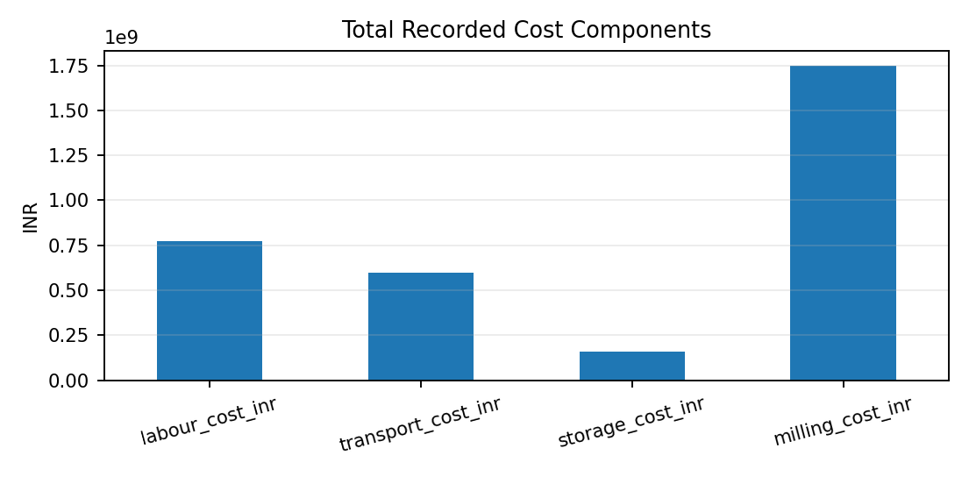
Cost component | Total recorded INR | Share of four-component total
labour_cost_inr | ₹771,647,426.17 | 23.6%
transport_cost_inr | ₹598,921,790.77 | 18.3%
storage_cost_inr | ₹156,796,701.00 | 4.8%
milling_cost_inr | ₹1,745,993,386.88 | 53.4%

Figure 6. Recorded cost components across all rows. Milling cost is the largest component in the synthetic file. This does not establish profitability: purchase cost of paddy, selling price, overheads, taxes, financing costs and the timing basis of each cost are not provided.

Data Quality & Validation
Check | Observed result | Implication
Row count | 100,000 | Reconciliation target
Missing cells | 1,499 | Review four fields with missing values
Exact duplicate rows | 0 | No exact duplicate rows found
Unique transaction IDs | 100,000 | Check whether all IDs are unique
Date coverage | 2022-07-01 to 2026-06-30 | Four years of records
Missing moisture | 600 | Do not impute without a rule
Missing electricity | 399 | Energy analysis may have smaller sample
Missing labour cost | 200 | Cost totals need complete-case logic
Missing actual delivery date | 300 | Exclude from delay calculation

Validation checklist
- Check numeric values for impossible negatives and extreme outliers.
- Check rice produced does not exceed processed paddy without a documented explanation.
- Confirm delivery-date order and missing actual dates.
- Review mill IDs that map to more than one district or capacity.
- Preserve raw columns and create explicit quality flags in Silver.

Python Data Preparation & Analysis
Python provides a reproducible path for loading the CSV, parsing dates, profiling missingness, creating derived measures and exporting summaries for the database and dashboard.

Example workflow
import pandas as pd
df = pd.read_csv("data/telangana_rice_mill_transactions_100k.csv")
df["transaction_date"] = pd.to_datetime(
df["transaction_date"], errors="coerce"
)
df["delivery_due_date"] = pd.to_datetime(
df["delivery_due_date"], errors="coerce"
)
df["actual_delivery_date"] = pd.to_datetime(
df["actual_delivery_date"], errors="coerce"
)
profile = pd.DataFrame({
"dtype": df.dtypes.astype(str),
"missing": df.isna().sum(),
"unique": df.nunique()
})
df["delivery_delay_days"] = (
df["actual_delivery_date"] - df["delivery_due_date"]
).dt.days
df.to_csv("outputs/validated_transactions.csv", index=False)
profile.to_csv("outputs/data_profile.csv")

Preparation decisions
- Keep the source unchanged and write processed outputs to a separate folder.
- Parse dates with errors reported or flagged.
- Use complete-case denominators when calculating date-based metrics.
- Export district, month, season, rice-type and cost summaries for reconciliation.

Analytical Modelling & Forecasting Scope
The current report prioritizes descriptive analytics because the supplied data is synthetic and includes transaction dates but no validated future target definition or external drivers. A forecasting model should be added only after choosing a business target and validating the time relationship.
Potential target | Candidate features | Evaluation design
Rice produced per mill-day | Lagged production, season, mill type, downtime, operating hours | Chronological holdout; compare seasonal-naive baseline
Delivery delay days | Mill type, district, season, quantities, downtime, date gaps | Train/test by time; report MAE and delay classification metrics
Electricity use per processed tonne | Processed tonnes, operating hours, rice type, mill type | Holdout by time or by mill; investigate leakage

Recommended first baseline
For a forecasting extension, aggregate production to mill × date, sort chronologically, train on earlier dates and test on later dates. Compare a simple last-observation or moving-average baseline against a model such as Random Forest. Never use actual delivery dates or future quantities as features for a prediction made before those events occur.

Evaluation metrics
- MAE: average absolute prediction error in target units.
- RMSE: penalizes larger errors more strongly.
- MAPE: can be unstable when actual values are zero or near zero.
- Report metrics by mill type and district to expose uneven performance.
No predictive performance score is claimed in this report because no model was run and validated as part of the document-generation step.

PostgreSQL & DBeaver Implementation
PostgreSQL is the relational database engine. DBeaver is a desktop client used to connect to PostgreSQL, import data, run queries and inspect results.

Suggested setup
- Create a dedicated database named rice_mill_analytics.
- Import the CSV into a staging table using explicit types.
- Create a fact table keyed by transaction_id after checking uniqueness.
- Add indexes on transaction_date, mill_id and district.
- Save queries and query outputs in the repository.
- Hide usernames, passwords and connection details in screenshots.

Example SQL
SELECT district,
COUNT(*) AS records,
SUM(rice_produced_tonnes) AS rice_produced_tonnes,
SUM(rice_delivered_tonnes) AS rice_delivered_tonnes
FROM fact_mill_transactions
GROUP BY district
ORDER BY rice_produced_tonnes DESC;
SELECT season,
SUM(paddy_processed_tonnes) AS paddy_processed,
SUM(rice_produced_tonnes) AS rice_produced,
100.0 * SUM(rice_produced_tonnes)
/ NULLIF(SUM(paddy_processed_tonnes), 0) AS conversion_pct
FROM fact_mill_transactions
GROUP BY season;
The example assumes the standardized table and column names shown. Adapt the names to the actual imported schema, then reconcile totals to Python.

Databricks & PySpark Processing Plan
Databricks provides a managed environment for Spark notebooks. PySpark supports distributed DataFrame operations and can process larger files or partitioned datasets using the same general transformation logic.

Notebook sequence
- Upload or access the approved CSV path in the workspace.
- Read the file into a Bronze DataFrame and capture ingestion metadata.
- Standardize field names, cast dates and numeric columns, and add data-quality flags.
- Write validated records to a Silver Delta table.
- Create Gold aggregates by district/month, season, mill type and rice type.
- Verify schemas, row counts and aggregate totals after writing.

Illustrative PySpark
from pyspark.sql import functions as F
raw = (spark.read.option("header", True)
.option("inferSchema", True)
.csv("/Volumes/<catalog>/<schema>/<volume>/rice.csv"))
silver = (raw
.withColumn("transaction_date",
F.to_date("transaction_date"))
.withColumn("ingestion_timestamp", F.current_timestamp())
.withColumn("quality_missing_moisture",
F.col("moisture_percentage").isNull()))
(silver.write.format("delta")
.mode("overwrite")
.saveAsTable("rice_analytics.silver_transactions"))
Replace the placeholder Volume path with a real workspace-approved path. This code is an implementation template, not evidence of a completed cloud run.

Power BI Dashboard Specification
Page | Question | Visuals | Slicers
Executive overview | What is happening overall? | KPI cards, monthly trend, production vs delivery | Date, district
Regional performance | Where is output recorded? | Top districts bar chart, district matrix | District, mandal, mill type
Production & yield | How do quantities compare? | Paddy processed vs rice produced, rice type chart | Season, rice type
Delivery monitoring | Which records are late? | Delay histogram, late records table | Due date, district, mill
Cost analysis | What makes up recorded cost? | Cost component bars, cost per processed tonne | Mill type, season

Suggested measures
Total Rice Produced =
SUM(FactMillTransactions[rice_produced_tonnes])
Total Rice Delivered =
SUM(FactMillTransactions[rice_delivered_tonnes])
Conversion Ratio % =
DIVIDE(
SUM(FactMillTransactions[rice_produced_tonnes]),
SUM(FactMillTransactions[paddy_processed_tonnes])
) * 100
Use consistent tonne units and INR formatting. Ensure the date table filters the fact table correctly. Do not claim the dashboard is complete until actual Power BI visuals have been built, refreshed and captured.

Recommendations & Implementation Priorities
Priority | Recommendation | Reason | Measure
1 | Resolve missing fields and confirm date logic | 1,499 missing cells; delivery timing drives analysis | Missingness rate; validated late-share
2 | Create a daily delivery exception list | Positive delay dates appear frequently | Late orders reviewed; average delay
3 | Monitor conversion ratio by mill and rice type | Production yield is a core process indicator | Weighted yield; outlier count
4 | Track cost per tonne processed | Cost totals vary with record volume | INR per processed tonne
5 | Compare mill types on normalized measures | Totals are affected by record counts | Output/record; cost/tonne
6 | Reconcile SQL, Python and Power BI | Prevents conflicting KPIs | Difference between systems = 0
7 | Pilot forecasting only after validation | Synthetic data limits real-world inference | Backtest vs naive baseline

Suggested 30-day plan
- Week 1: confirm field definitions, resolve missingness policy and validate data grain.
- Week 2: build PostgreSQL schema and SQL KPI outputs; reconcile with Python.
- Week 3: implement Databricks/Delta layers and Power BI prototype.
- Week 4: review outputs with a domain stakeholder and document gaps before any operational pilot.
Do not claim financial savings in advance. Establish a baseline and success thresholds before testing any process change.

Limitations, Risks & Governance
Risk | Potential impact | Mitigation
Synthetic dataset | Findings may not reflect real mill operations | State provenance; validate on approved operational data
Missing fields | Biased cost or delay summaries | Report denominator and use explicit quality flags
Date semantics unclear | Incorrect lateness interpretation | Confirm whether dates refer to the same order/cohort
Cost fields incomplete | Misleading cost/profit conclusions | Label totals as recorded components; add omitted costs
Potential data leakage | Unrealistic forecast score | Use time-aware splits and only information available at prediction time
Cross-tool mismatch | Dashboard trust reduced | Maintain KPI dictionary and automated reconciliation
Credential exposure | Unauthorized workspace/database access | Use secrets/environment variables; exclude from Git

Responsible use
This prototype should support human review rather than automate mill decisions. Before operational deployment, establish data ownership, access controls, refresh monitoring, correction procedures, backup/retention policy and a rollback process.

Conclusion & Future Work
This project demonstrates a structured approach to analyzing 100,000 synthetic rice-mill transaction records across 33 districts and 500 mill identifiers. The dataset contains paddy receipt and processing quantities, rice production and delivery, operating indicators, costs and delivery dates.
The key descriptive totals are 4,127,695.36 tonnes of paddy received, 3,357,466.83 tonnes processed, 2,242,223.24 tonnes of rice produced and 1,928,388.49 tonnes delivered. The aggregate conversion ratio is 66.78%. These figures describe the supplied synthetic data only.
The central lesson is that reliable analytics depends on source provenance, clear definitions, consistent data grain, visible data-quality checks and cross-tool reconciliation—not simply on the number of tools used.

Future work
- Replace synthetic data with approved, real operational records.
- Confirm the meaning and timing of pending-delivery and cost fields.
- Add paddy purchase price, rice sales value, energy tariff and operating context to estimate profitability.
- Run a time-based forecasting experiment and compare against naive baselines.
- Complete Databricks/Delta execution and capture real table evidence.
- Build and refresh Power BI pages, then reconcile all totals to PostgreSQL.
- Publish a clean GitHub repository with reproducible instructions and no secrets.

Final assessment
The report is a reproducible academic blueprint based on the provided CSV. Tool execution, dashboard publication and model validation must be demonstrated separately before describing them as completed.

Appendix: Reproducibility & Submission Checklist
Item | Evidence to include | Status
Dataset profile | File, shape, date range, missingness, duplicate checks | Calculated from supplied CSV
Python | Script, requirements, run log, exported summaries | Package and run locally
PostgreSQL / DBeaver | Schema, imported tables, saved SQL and totals | Capture actual screenshots
Databricks / Delta | Notebook run, table paths and row counts | Complete only after successful run
Power BI | Dashboard pages, slicers and refreshed totals | Capture actual screenshots
GitHub | README, code, SQL, notebook, report and dataset note | Create repository and verify URL
Final report | Student/faculty details, page count, citations and formatting | Review before submission

Suggested repository structure
rice-mill-bigdata-analytics/
├── data/ # Add data only if permitted
├── python/
│ ├── profile_data.py
│ └── analysis.py
├── sql/
│ ├── schema.sql
│ └── analytics.sql
├── databricks/
│ └── rice_mill_pipeline.py
├── powerbi/ # PBIX or screenshots, if available
├── outputs/ # Aggregates and validation summaries
├── report/
│ └── Telangana_Rice_Mill_Big_Data_Report.docx
├── requirements.txt
└── README.md

Reproducibility commands
pip install pandas numpy matplotlib scikit-learn sqlalchemy psycopg2-binary
python python/profile_data.py --input data/telangana_rice_mill_transactions_100k.csv --output outputs
Final note: this Word report is 30 manually structured sections/pages. Verify the rendered pagination in Microsoft Word and replace any placeholders or planned-tool descriptions with genuine execution evidence before submission.

